Title:
Smartphone-based colorimetric reader for bioanalytical applications using tablet’s/smartphone’s screen-based bottom illumination
Authors & affiliations:
Sandeep Kumar Vashist^{1,2*}, Thomas van Oordt¹, Felix von Stetten^{1,2}, Roland Zengerle^{1,2}
¹ HSG-IMIT - Institut für Mikro- und Informationstechnik, Georges-Koehler-Allee 103, 79110 Freiburg, Germany.
² Laboratory for MEMS Applications, IMTEK – Department of Microsystems Engineering, University of Freiburg, Georges-Koehler-Allee 103, 79110 Freiburg, Germany.
*Corresponding author’s e-mail: sandeep.kumar.vashist@hsg-imit.de
Abstract: (Your abstract must use Normal style and must fit in this box. Your abstract should be no longer than 300 words. The box will ‘expand’ over 2 pages as you add text/diagrams into it.)
We have developed smartphone-based colorimetric readers (SBCR)¹ for bioanalytical applications using tablet’s/smartphone’s screen-based bottom illumination (Fig. 1A). The tablet and smartphone employed for the bottom illumination were iPAD mini and iPhone 5s, respectively, while Samsung Galaxy SIII mini’s back camera was used for colorimetric imaging. The tablet’s/smartphone’s screen provided highly uniform bottom illumination through inbuilt screensavers, which transmitted white light only in the specific regions corresponding to the bottom of microtiter plate wells. The developed SBCR does not employ any optical attachment and can detect the colorimetric products within the visible region. It was used for one-step kinetics-based human C-reactive protein (CRP) immunoassay in whole blood, serum and buffer (Fig. 1B-D), where the formation of sandwich immune complex was detected by colorimetric product formed in 3,3′,5,5′-tetramethylbenzidine (TMB) substrate reaction. It was further tested for bicinchoninic acid (BCA) protein assay². The MTPs (96 or 24 wells) containing the colorimetric products were placed on the tablet’s/smartphone’s screen and then imaged by the smartphone’s camera inside an optically-opaque hood (Fig. 1A). The pixel intensity of the acquired image was determined by an image-processing algorithm programmed in MATLAB. The intensities of the blue and green channels were measured for the colorimetric products that were formed in the TMB substrate reaction-based human CRP immunoassay and BCA protein assay, respectively. The developed low-cost SBCR-based assays (Fig. 1B-C, E) had same sensitivities as the conventional assays performed using highly expensive MTP plate reader (US$ 25,000) (Fig. 1D-E). The developed SBCR was further used for monitoring various colorimetric products formed in in vitro diagnostics (IVD) and bioanalytical sciences. It can be employed for colorimetric determination in a wide range of IVD, lab-on-a-chip, microfluidics, lateral flow and other bioanalytical platforms that are transparent and flat. Being highly affordable, it can form an integral part of all bioanalytical laboratories.

References:
- Vashist, S.K., Venkatesh, A.G., Czilwik, G., 2013. Easy ELISA formats and products thereof. European Patent Application No. EP13172022.9.
- http://www.piercenet.com/instructions/2161296.pdf

(A)
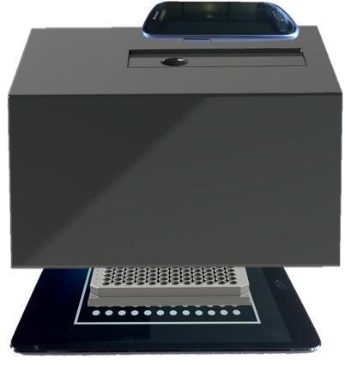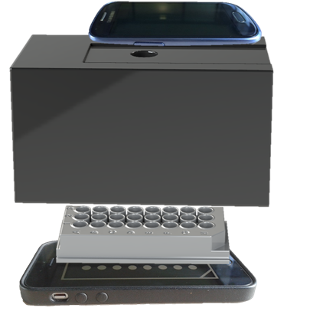

(B) (C)
(D) (E)
Figure 1. Smartphone-based colorimetric reader (SBCR) for bioanalytical applications using (A) iPAD mini’s (left) and iPhone 5s’s (right) screen-based bottom illumination. Human CRP immunoassay on (B) iPAD mini and (C) iPhone 5s screens. (D) Conventional human CRP immunoassay on 96-well microtiter plate reader, (E) Bicinchoninic acid protein assay on iPAD mini’s and iPhone 5s’s screens.

